Usama Ejaz

247644

**CS-344: Web Engineering**

**Lab 01: Introduction to DreamWeaver and HTML**

# Department of Computing

**CS-344: Web Engineering**

**Class:** BESE-9AB

# Lab 01: Introduction to DreamWeaver and HTML

**Date: October 15, 2020**

**Time 10:00am to 1pm & 2pm to 5pm**

# Instructor: Dr. Qaiser Riaz

**Name: Usama Ejaz**

**CMS: 247644**

# 

# Lab 01: Introduction to DreamWeaver and HTML

### Introduction:

Students will familiarize themselves with DreamWeaver and will practically learn basic concepts of HTML.

### Lab Objectives:

This objective of this lab is to help students in setting up their systems for web engineering and familiarizing themselves with the development environments for HTML and basic concepts of HTML.

### Helping Material:

<https://www.w3schools.com/html/default.asp>

### Lab Tasks

### Task 1

With the help of Lab Engineer, install on your laptops important tools for Web Engineering such as Apache2 Web Server, PHP5, MySQL, DreamWeaver, and Eclipse for PHP etc.

### Task 2

Visit W3Schools website mentioned above. Read following three sections on the website:

* HTML Introduction
* HTML Editors
* HTML Basic

Your task is to first familiarize yourself with the following HTML tags: **DOCTYPE**, HTML, BODY, Headings (H1, H2, H3, H4, H5, H6), HTML Paragraphs (<P>), and HTML Links (<a>). Once you have learned these tags, you have to create a personal HTML page similar to the following image:

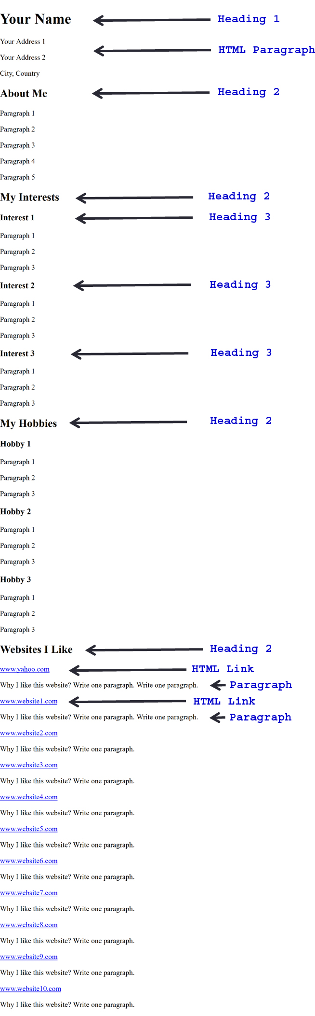

**Answer:**

|  |
| --- |
| Solution |
| Screenshot of task 2  C:\Users\domain1\AppData\Local\Microsoft\Windows\INetCache\Content.Word\1.png  C:\Users\domain1\AppData\Local\Microsoft\Windows\INetCache\Content.Word\2.png  C:\Users\domain1\AppData\Local\Microsoft\Windows\INetCache\Content.Word\3.png  C:\Users\domain1\AppData\Local\Microsoft\Windows\INetCache\Content.Word\4.png  HTML Code  <!doctype html>  <html>  <body>  <h1> Usama Ejaz </h1>  <p> Address 1: Kashmir Road, Block-X, District Gujranwala </p>  <p>Address 2: Kareem pura, Tehsil Wazirabad, District Gujranwala </p>    <h2> About Me</h2>  <p> I am an undergraduate Software Engineering student at National University of Sciences and Technology. I have a passion for technology and innovation. </p>  <p> I like to code and develop full stack applications. I have been a Software Suality Assurance Intern at Afiniti. I have also been a Research Intern at TUKL Lab, SEECS.</p>  <p> I am director Social Media Marketing at Youth Entreprenuerial Society (YES). I am also a deputy director Social Media Marketing at Seecs-Government Association (SGA). </p>  <p> I also do freelance projects. You can contact me <a href="Freelancer.com/u/UsamaEjaz0">here.</a> I have a good online reputation with perfect 5-star reviews from clients for over 35 projects.</p>  <p> If you want to know more about me, you can visit my LinkedIn <a href = "https://www.linkedin.com/in/usamaejaz0/">profile</a>. I have 96 reputation on Stack Overlfow. I am also an open source contributor on Github. You can visit my <a href = "https://github.com/usamaejaz0"> profile</a> to know more about me.</p>  <h2>My Interests</h2>    <h3>Digital Marketing</h3>  <p> I have a profound interest in digital marketing. It includes Social Media Marketing, Search Engine Optimization etc. I have also worked on Google ads compaigns at Boosters Designs, Karachi, </p>  <h3>Full Stack Development</h3>  <p>I have an interest in full stack mobile, web and desktop development. I can make beautiful desktop applications in JavaFx. I am also learning flutter to develop cross-platoform applications. </p>  <h3>Machine Learning</h3>  <p>Machine learning also attracts me and catches my interest. I have been a Deep Learning Research Intern at TUKL Lab, SEECS. My project was classification and localization of chest X-Ray Images using Bounding Boxes. I also made a small facial recognition system using transfer learning for my supervisor and myself.</p>    <h2>My Hobbies</h2>  <h3>Chess</h3>  <p> I like to play chess a lot. I have a rating of 1588 on <a href = "Chess.com"> www.chess.com</a> I also regularly follow Grand Masters and International Masters like Magnus Carlsen, Hikaru Nakamura, Eric Rosen and Ben FineGold. </p>  <h3>Watching movies and anime</h3>  <p> I watch TV-Series or anime when I'm free. I have seen more than 20 anime series. My favourite genre is thriller, mystery and action. </p>  <h3>Gaming</h3>  <p>I play Call of Duty 4: Modern Warfare back in the days. My favourite was the Persia of Persia series. I sometimes play android games like Among Us, PUBG, Need for Speed and PaperIO.</p>  <h2>Websites I like</h2>  <a href = "www.youtube.com">www.youtube.com</a>  <p>I like the UI and overalll design of youtube. Youtbe is also faster than any other video streaming website in Pakistan because it has a Content Distribution Network in Pakistan. I also like the recommendation system being used on youtube. </p>  <a href = "www.facebook.com">www.facebook.com</a>  <p>Facebook has recently introduced a dark theme for both website and mobile app. I really like it. Facebook is easy to use, fast and has many disinguishable features. That is why I like Facebook.</p>  <a href = "www.chess.com">www.chess.com</a>  <p>I like to play chess, there are many great chess apps like lichess and chess24 but I like chess.com as it has a beautiful User Interface and it is very smooth.</p>  <a href = "www.github.com">www.github.com</a>  <p>Github is one of the best version control systems out there. Github is so great that Microsoft acquired GitHub for $7.5 billion in stock. </p>  <a href = "www.alminhajuniform.com">www.alminhajuniform.com</a>  <p>This is my one of the very first websites. This is my father's website developed by me. It is a static website and one of my very first websites. I I'll update it Insha Allah after this course.</p>  </body>  </html> |

### Deliverables

Compile a single word document by filling in the solution part and submit this Word file on LMS. You must include your name, ID, and class on first page. The lab grading policy is as follows: The lab is graded between 0 to 10 marks. For some of the labs, students have to present their solutions in a viva session. In case of any problems with submissions on LMS, you should contact your lab engineer Mr. Aftab Hussain by email at [aftab.hussain1@seecs.edu.pk](mailto:aftab.hussain1@seecs.edu.pk).